GNS3 Lab

Purpose

In this lab, we were assigned to set up GNS3 and get it working so we could do our labs from home. Due to the current world crisis, we are unable to work directly in the lab, so we decided to use GNS3 to work from home as it is very good at simulating a lab environment. The first lab we are doing with GNS3 is the VRF-Lite lab, which I have already completed in GNS3. While we won’t be able to work in a lab at school, GNS3 will let us learn all the new concepts we need to learn before the school year ends.

Background Information

Graphical Network Simulator-3, or GNS3, is a network software emulator released in 2008. It allows the use of virtual and real devices which are then used to simulate complex networks. GNS3 uses Dynamips emulation software to simulate Cisco IOS. Dynamips is an emulator program that can emulate Cisco routers, and it can be used on GNS3 without any external programs. If you want to use devices that are not included in Dynamips, you need to install VMWare Workstation and launch a GNS3 VM. VMWare Workstation is an application that allows you to run virtual operating systems or virtual machines (VMs) on your computer without needing extra hardware. You can use it with GNS3 by creating a GNS3 VM that connects to the GNS3 application to allow you to run IOSv images, IOU images, ASAv, or create complex network topologies. GNS3 is very useful and is used by many large companies such as Exxon, Walmart, AT&T, NASA, and more.

Lab Summary

For this lab, the goal was to install VMWare Workstation, add a GNS3 VM to it, and get it all running through the GNS3 application. The first thing I did was setup VMWare Workstation. I installed it from the link that our teacher gave us, and I then followed the installer to get it working on the computer. I then went through the installer again so it was updated and would run on the latest version. Next, I opened up the GNS3 VM through the GNS3.ova file that was downloaded and was able to get that working. Next, I had to install GNS3, so I also followed the installers instructions and was able to successfully install it. Once inside GNS3, I had to make sure that it connected to the GNS3 VM in VMWare, and once it did, I was all set to start completing my assigned labs. After this, I was able to successfully setup and complete my VRF lab through GNS3

Lab Commands

Because the lab assignment was to set up GNS3, I didn’t use any lab commands while setting up GNS3. I did however use multiple new lab commands when I was configuring VRF. I had to use the command “ip vrf 10” to set up each VRF. Then, I had to forward the VRFS on the subinterfaces using the command “ip vrf forwarding 10.” Finally, I also used OSPF for VRFs by using the command “router ospf 1 vrf 10.”

Problems

With this lab, I had one major problem with setting up GNS3 that had me stumped for about a week. When I was setting it up on my desktop PC, the GNS3 VM wasn’t working correctly. VMWare Workstation was not connecting to my ethernet connection, and that made the GNS3 VM not work at all. I tried many things to get it working, such us updating drivers, reinstalling drivers, looking online for solutions, installing other software, but nothing was working. Eventually, I decided I would try to get it working on my mac to see if the problem persisted there. I followed through with the exact same steps as on my PC, but it worked perfectly on my mac. I unfortunately do not know why it did not work on my PC, but at least I got it fully working on my mac and can get labs done from there.

Conclusion

Overall, in this lab I successfully installed and configured VMWare Workstation, the GNS3 VM, and GNS3 and got them all working together to complete my VRF-Lite lab. While I did have some major problems when trying to set it up on my PC, I was able to get it working on my Mac instead. This lab helped teach me more about VMWare and GNS3, how they work, and how to troubleshoot them when they are working incorrectly.

Lab Diagram

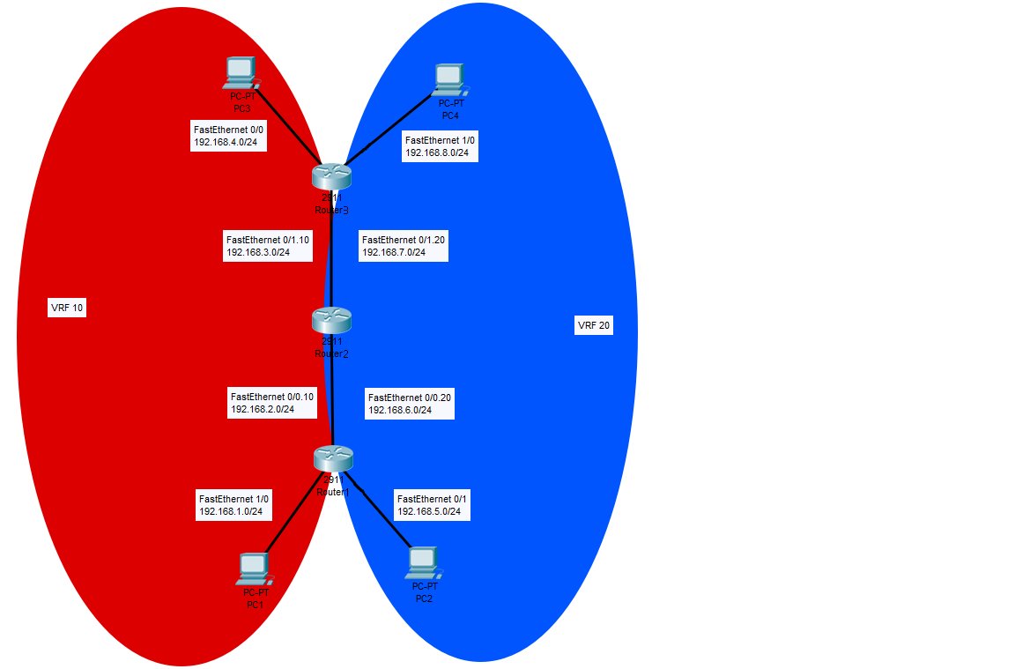

Setting Up VMWare and GNS3

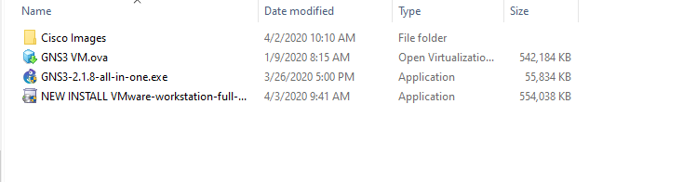The first step to installing and setting up GNS3 is to have downloaded from the internet the GNS3 installer, the VMWare installer, the GNS3 VM file, and the Cisco router images. You will also need a license key for VMWare

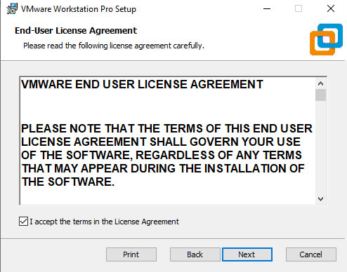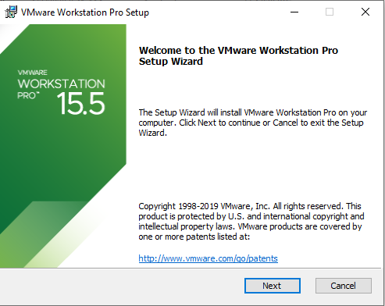The next step is to begin installing VMWare Workstation by opening the installer and following its instructions

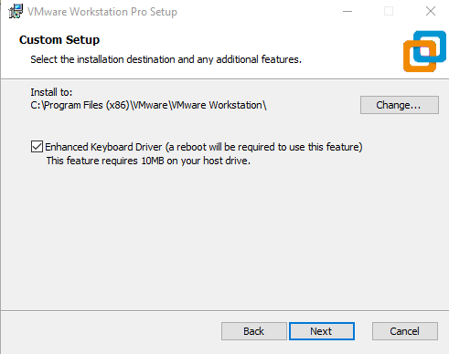Make sure to enable the Enhanced Keyboard Driver and to set the installation to a desirable location

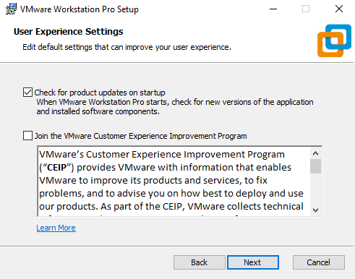Next, make sure to turn uncheck “Join the VMware Customer Experience Program,” and keep the check for updates box checked, as we will need to update it later. Also, you can set the shortcuts to whatever you prefer.

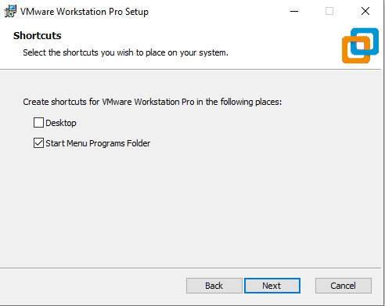

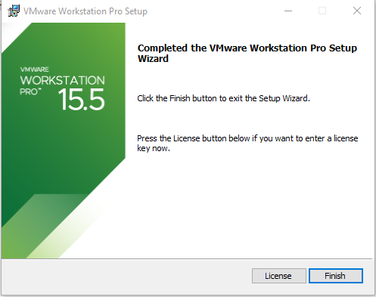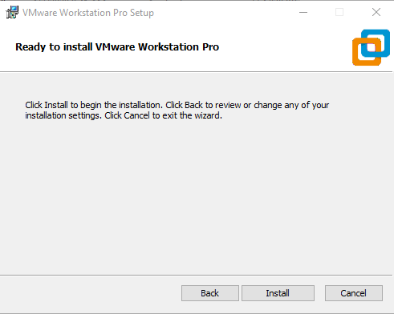Next, just press install and wait for it to finish. Once finished, either press finish or press License to activate your license key. Make sure to restart your computer afterwards when prompted.

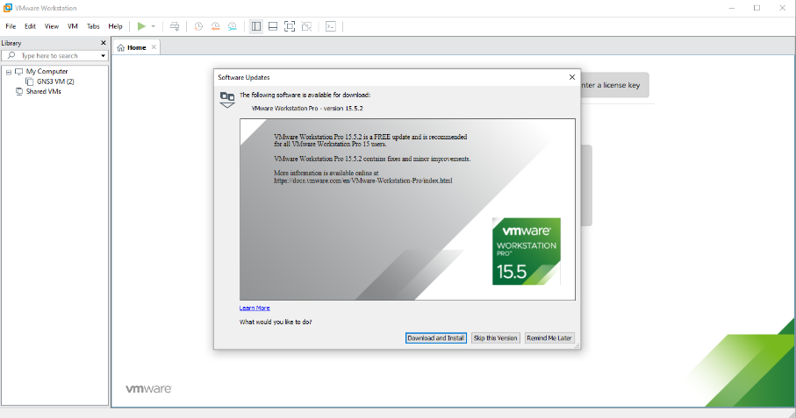Once you have restarted, you need to open VMWare Workstation. Once you do, you will be prompted to download an update. Press the download button to install the update.

Once you press download and install, you will once again be prompted to install VMWare Workstation. Follow the installation with the exact same steps as used previously and it will update your current version of VMWare. Make sure to put in your license key with this installation if you hadn’t previously.

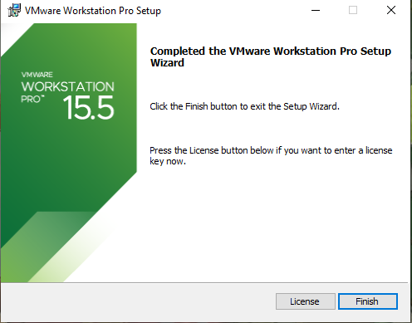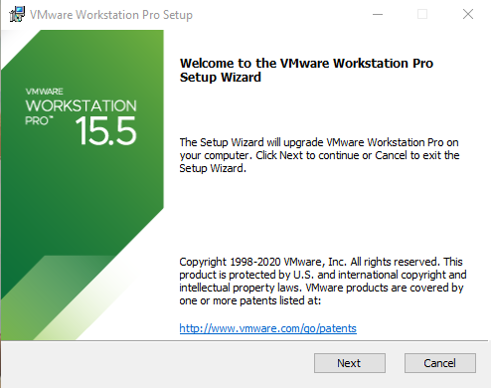

The next thing you need to do is to open VMWare, and open the GNS3 VM. For this, you simply need to select “Open a Virtual Machine,” and then select your GNS3.ova file. Once you select the file, press import, and it will import the VM into VMWare.

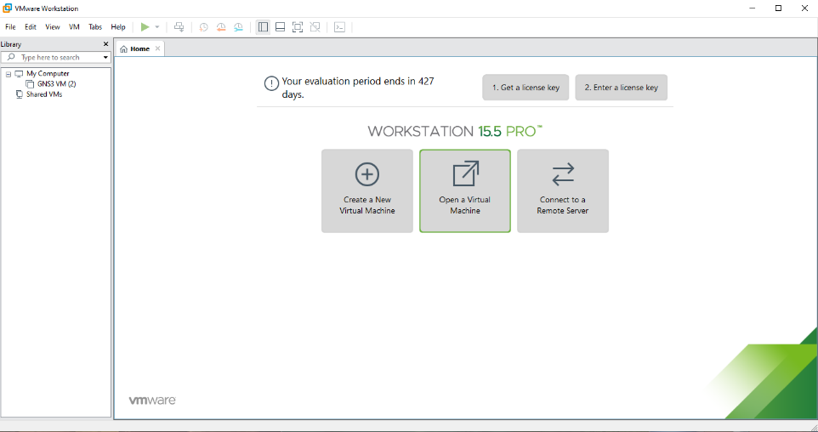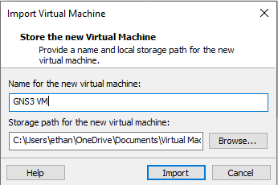

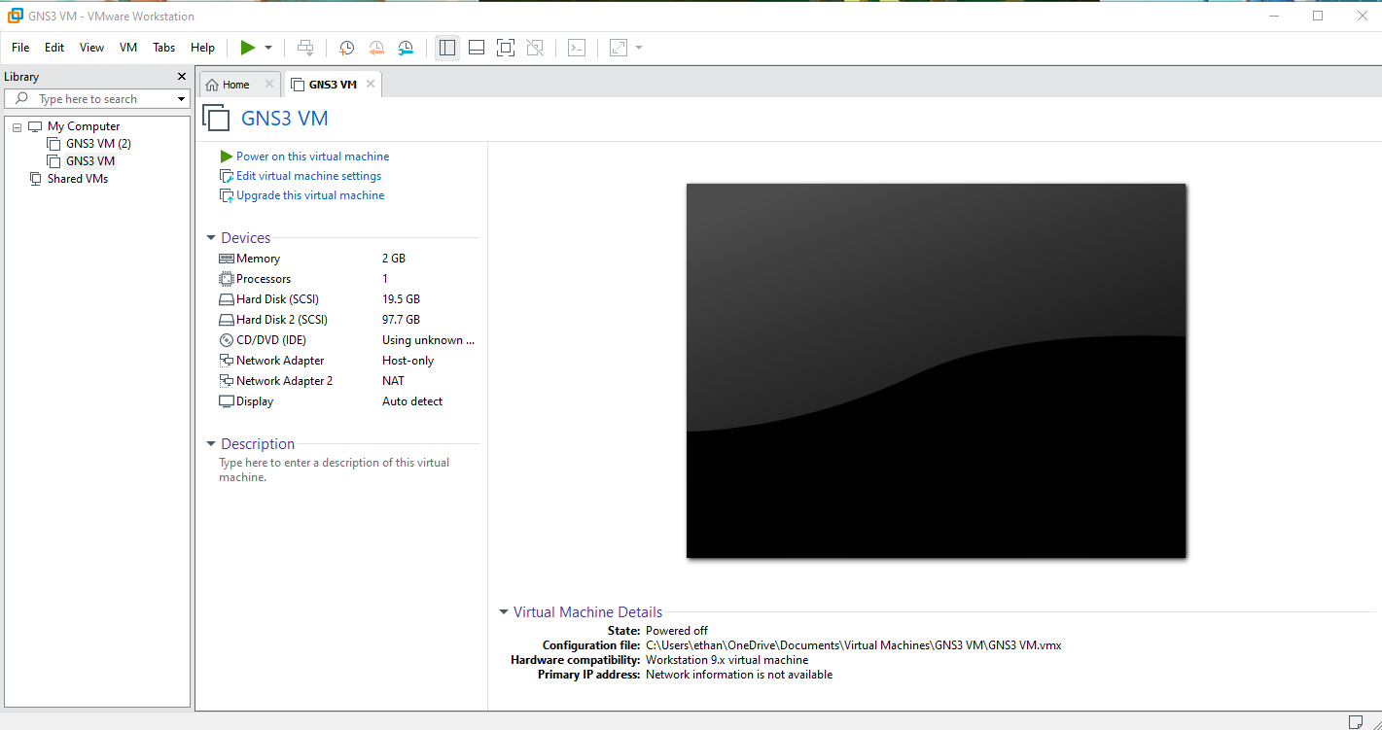Next, power on the VM by pressing “Power on this virtual machine,” and then minimize it while we install GNS3.

To install GNS3, run the GNS3 all-in-one installer and follow the prompt it gives you by pressing next and agreeing with the License Agreement.

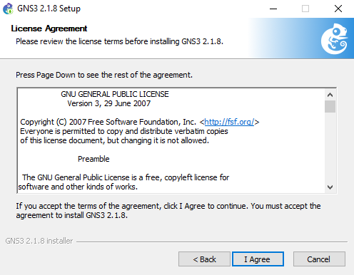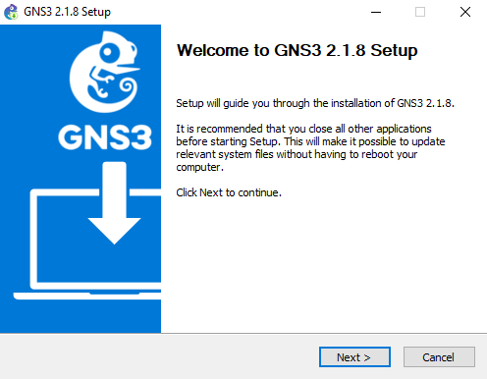

Next, on the choose components screen, make sure you uncheck Wireshark, VirtViewer, SolarWinds, and Npcap. Then, press next.

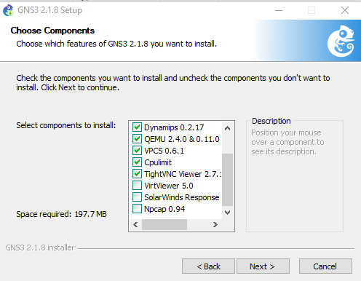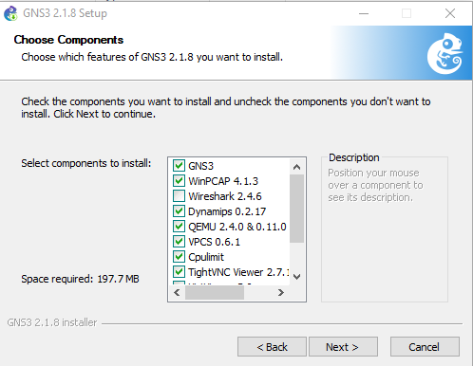

Then, select where you want it to download and press install. Once it is completed, press next.

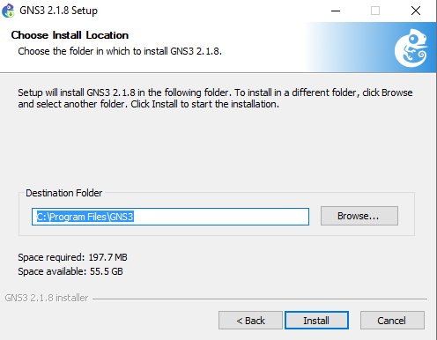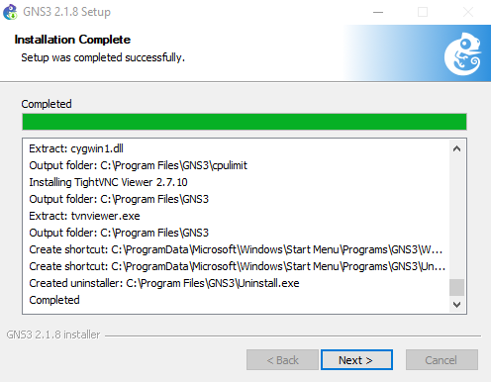

Next, make sure to select No for installing SolarWinds, press next, and launch GNS3.

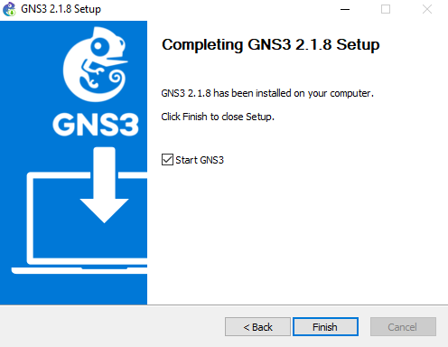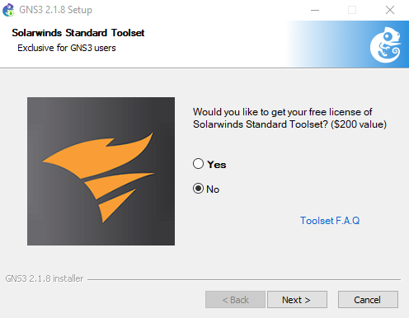

Once you are in GNS3, you will be prompted to select a server location. Simply continue pressing next without changing the setup, unless you want to change the server path.

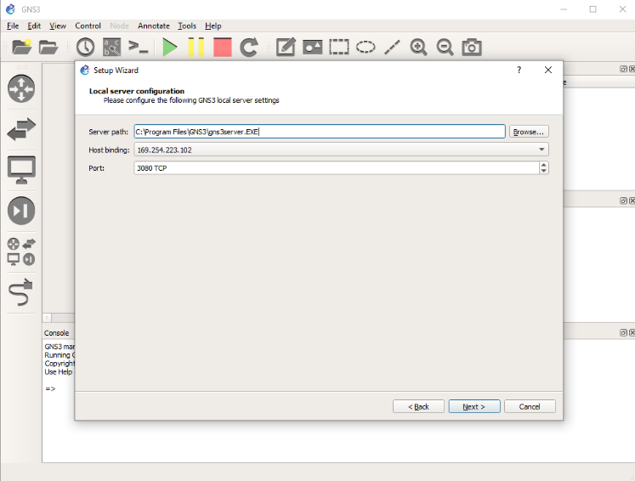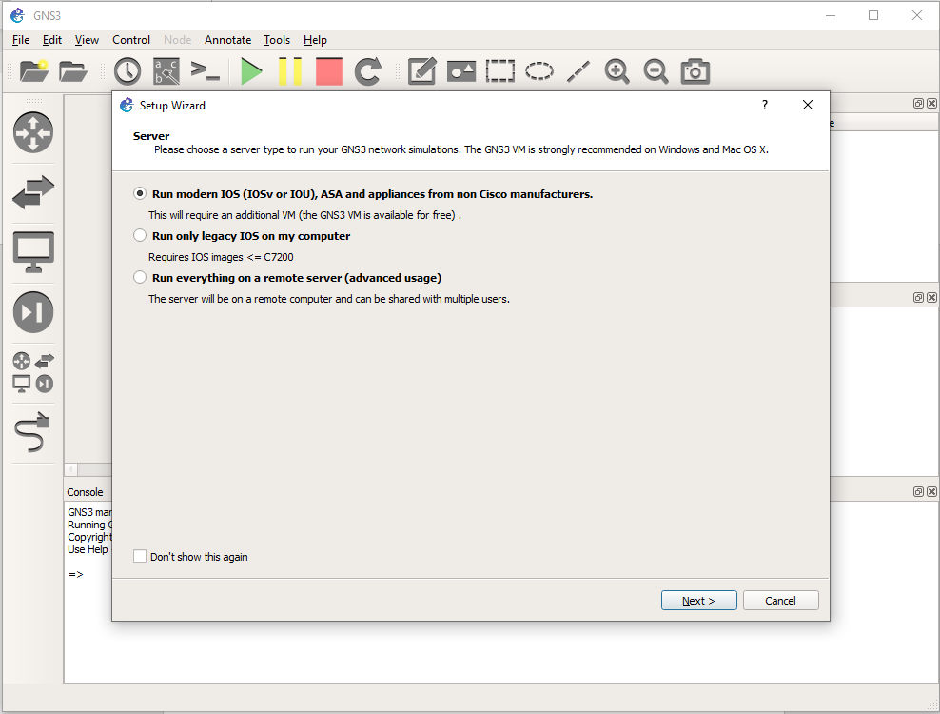

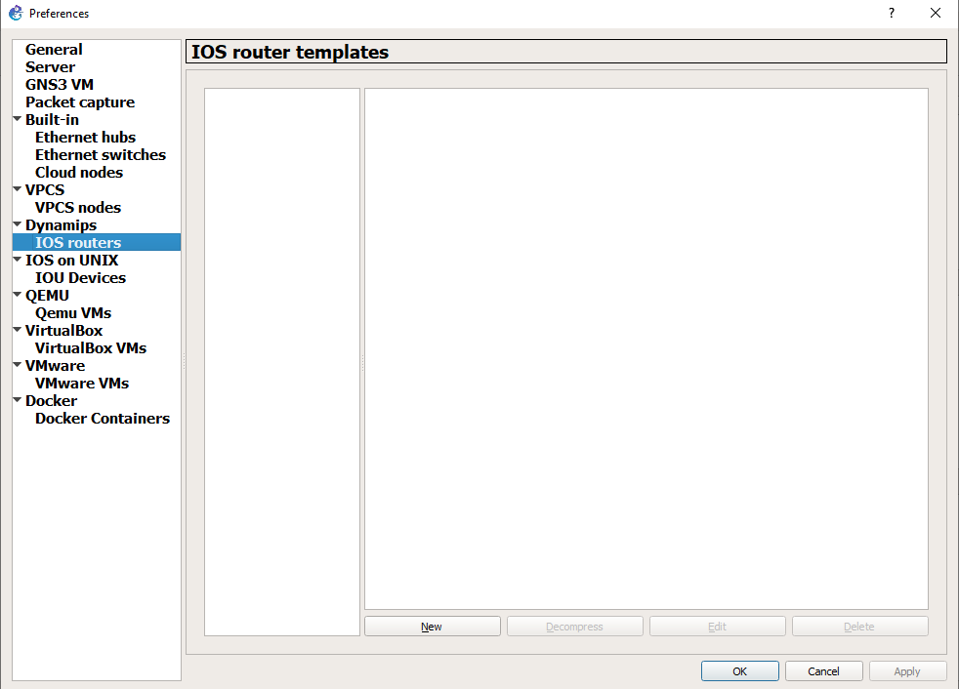Finally, now that GNS3 is working, you need to add the routers to it. To do that, you first need to go to preferences in the edit tab, and then click on the IOS Routers sidebar.